Task 18

Q1.create account in facebook :

Navigate the facebook website:www.Facebook.com

Click the create account button .

Its navigate the another page

Give all the information and clik signup button

Script:

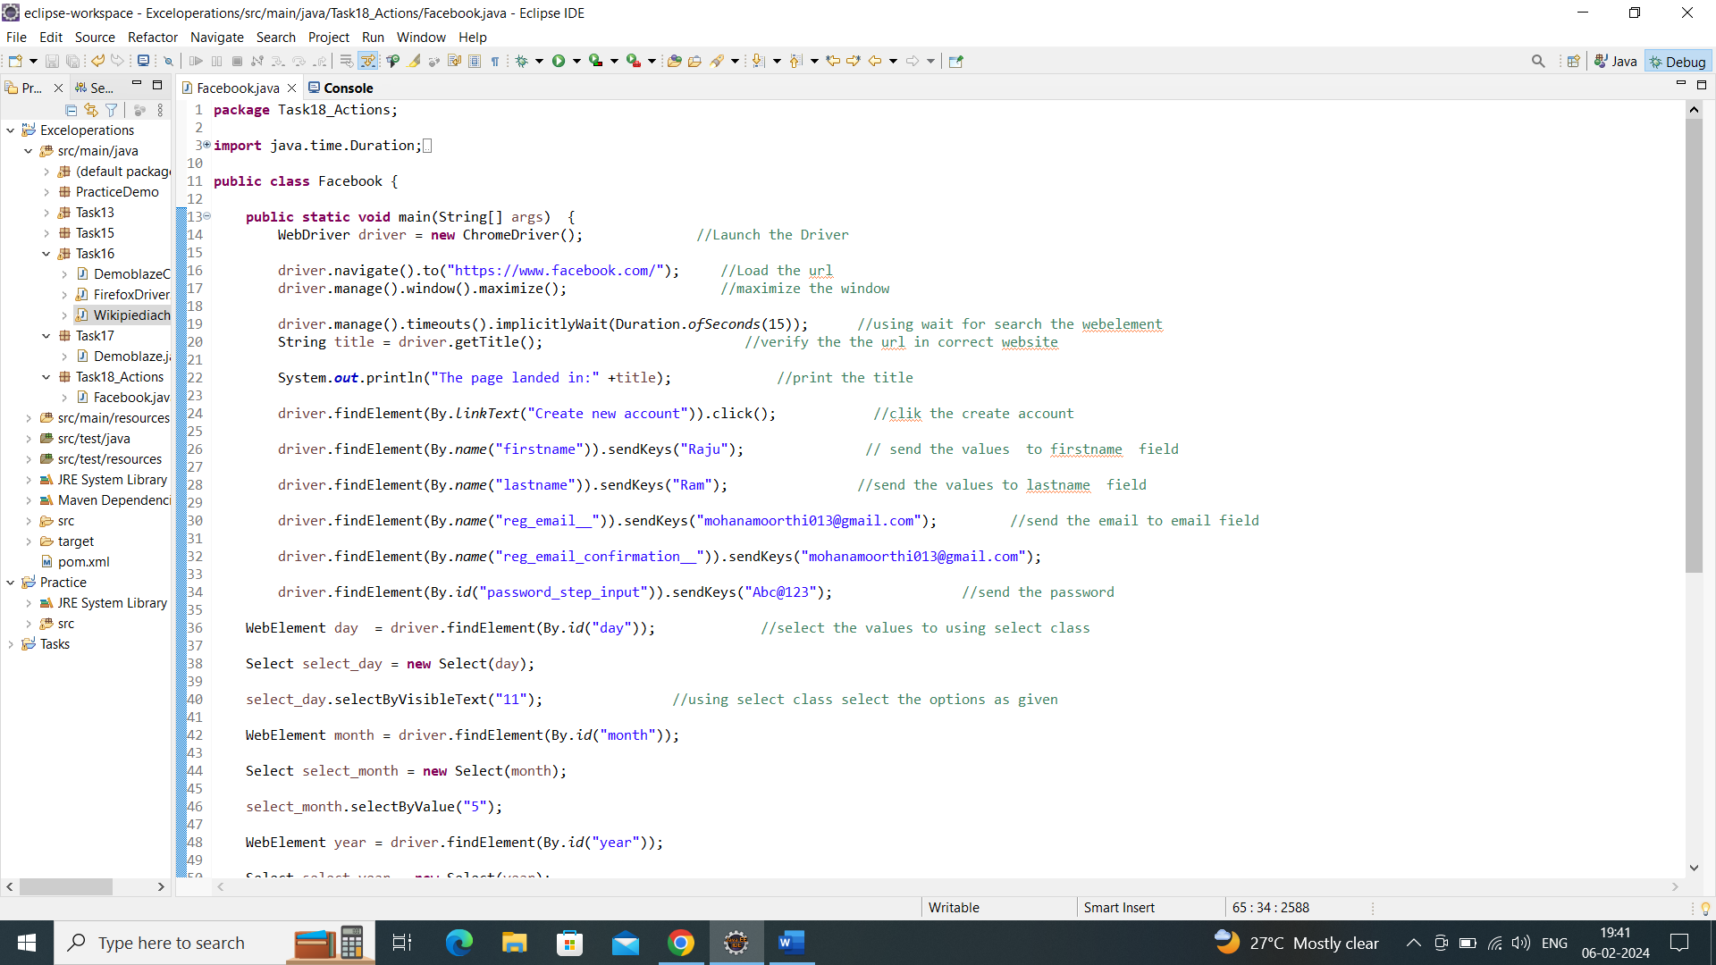

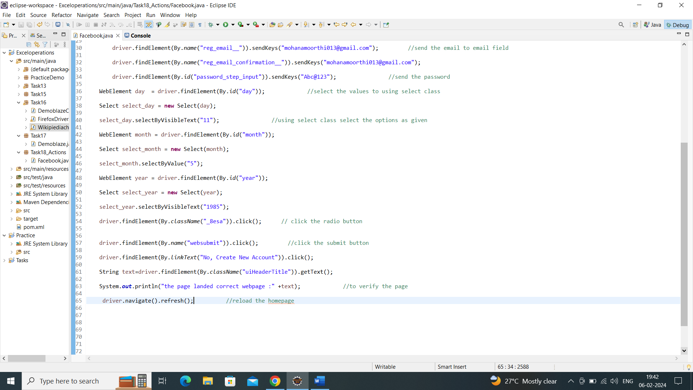

Output:

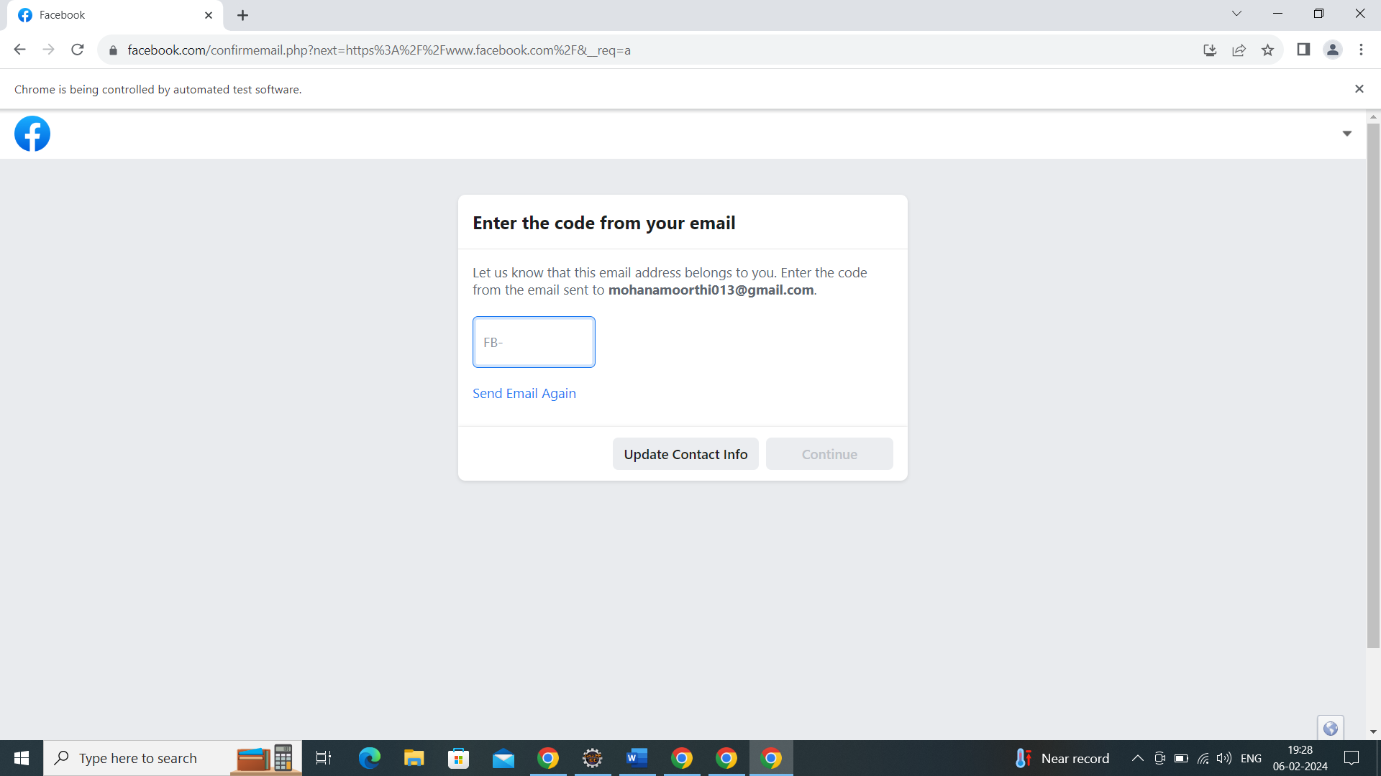

Console output:

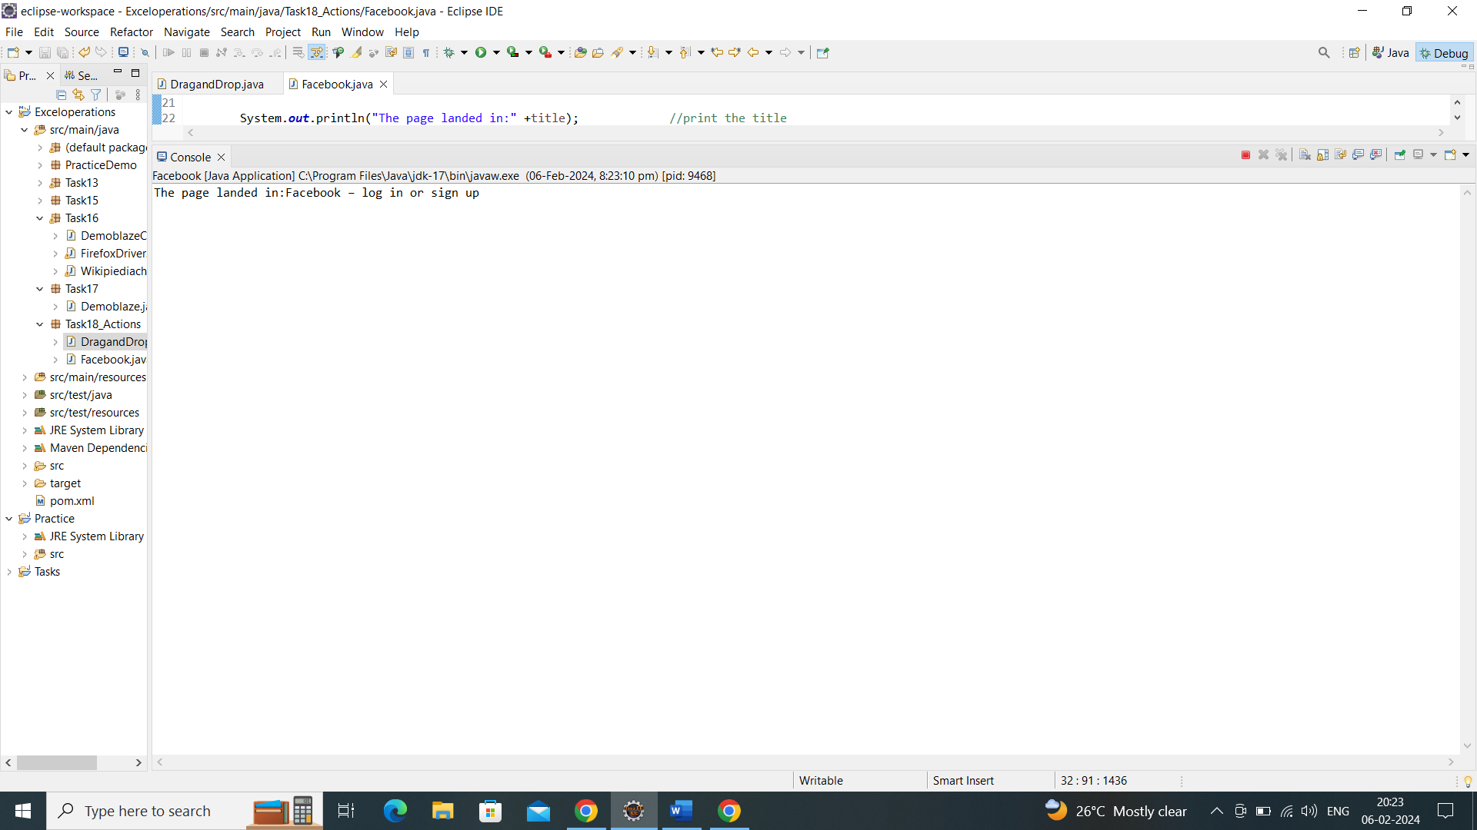

Q2 Drag and drop using Actions class:

Navigate the url: "https://jqueryui.com/droppable/

Find the source element to drag

Find the destination element to drop

Then perform the drag and drop action.

Script:

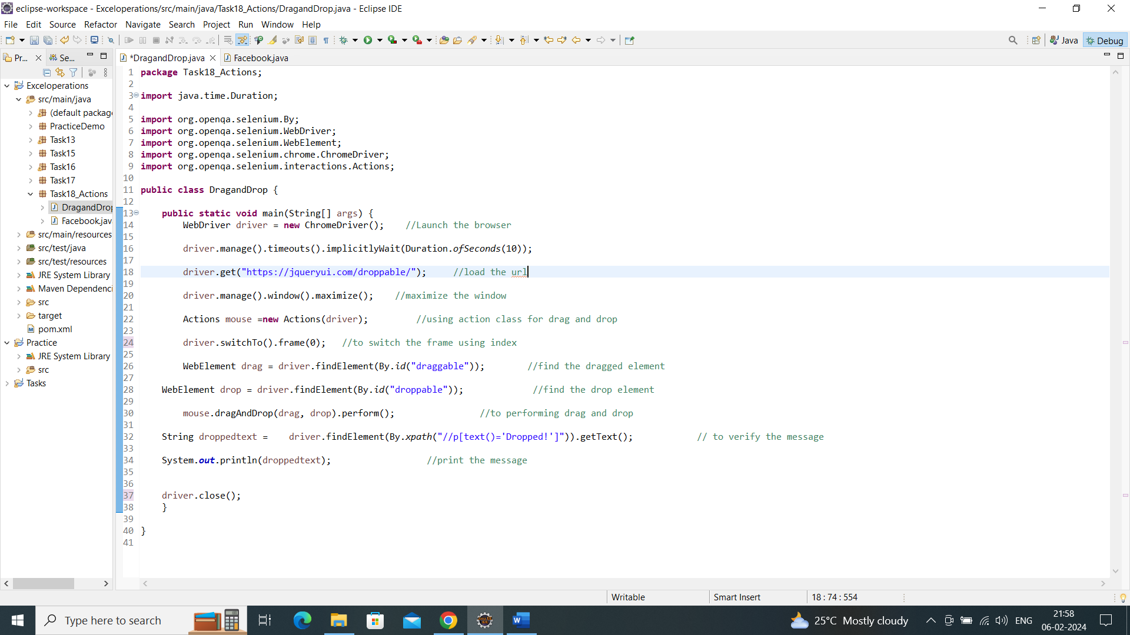

Output:

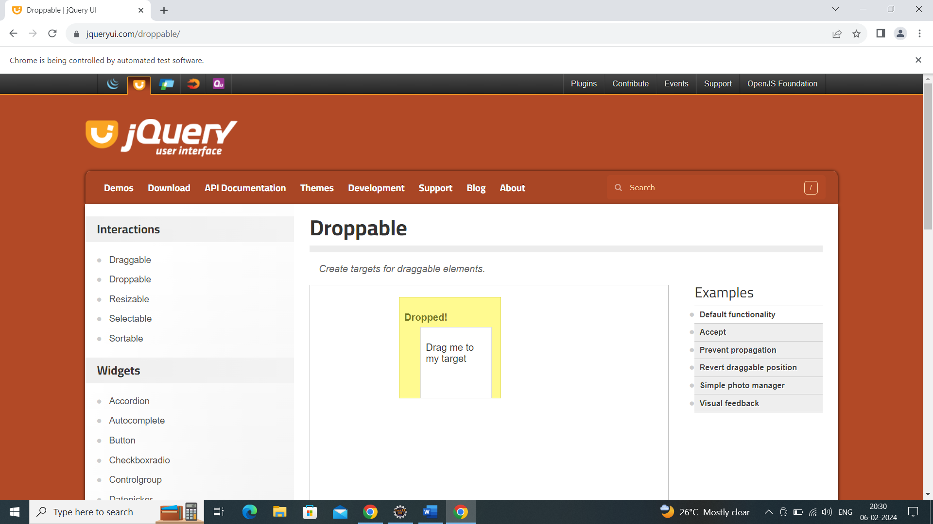

Console output:

Verification message

